Apprication Note
As this help document can not find needed solutions to problems , please send an email to cjinzong@arkmicro.com or call 0755-86169590 15986768226 ( Chen ) QQ: 282280945. We will respond as soon as possible to solve your questions, thank you !

Help document version update description:
V1.0.0
AMT630A Help document initial release.

V1.0.1
1. Increase (adjust the screen debugging notes document).
2. Add (AMT630A timing configuration details)
3. (AMT series of IC PCB layout design recommendations) to increase the 11,12 points, to prevent power supply interference layout considerations.
4. An increase of customer production (program burn bad) causes and solutions.

V1.0.2
1. Added video training tutorial list.
2. An increase of the AMT630A production layout instructions (production board layout instructions)

The Difference between AMT630A and AMT630
AMT630A amelioration of AMT630 is based on the modified screen compatible and signal compatibility, image quality has been raised, mainly in the field of noise dark spots have significantly improved. In addition, the application also has improved, user-friendly debugging.

Performance mainly reduce system power consumption, the normal operating current of about 3.3V 60ma, standby function do about 10ma. ESD upgrade from 4K to 8K, EMC EMI so do the corresponding improvement and upgrading.

AMT630A use I2C debugging and upgrade, and a mouth (3pin SDA, SCL, GND) debugging and upgrades. See (debug tool board instructions)

Framework SDK is the same, if customers do not want to use the new SDK to develop, you can use AMT630 software, the underlying AMT630A the transplant can be. See (how the underlying drivers AMT630 replace AMT630A)
PC Tools is optimized, the original use of screen parameters do ARK_DEBUG debugging, ARKwriter do download now just use a debugging tool to achieve two functions. See (ARK_DEBUG debugging instructions, ARK_DEBUG download instructions), but need to be kept informed AMT630 still need the original debugging tools to debug, debugging tools can not be used AMT630A.

OSD mainly modify the overall size of the logical material modifications and assets substantially unchanged. See (OSD Resource Description)
I -
I- A MCU-8051
AMT630A embedded within a high-speed 8051 MCU, instruction execution speed is three times the normal 8051 , other peripherals and access control as methods .
I – B GPIO Resources
Pin Functions of AMT630A:
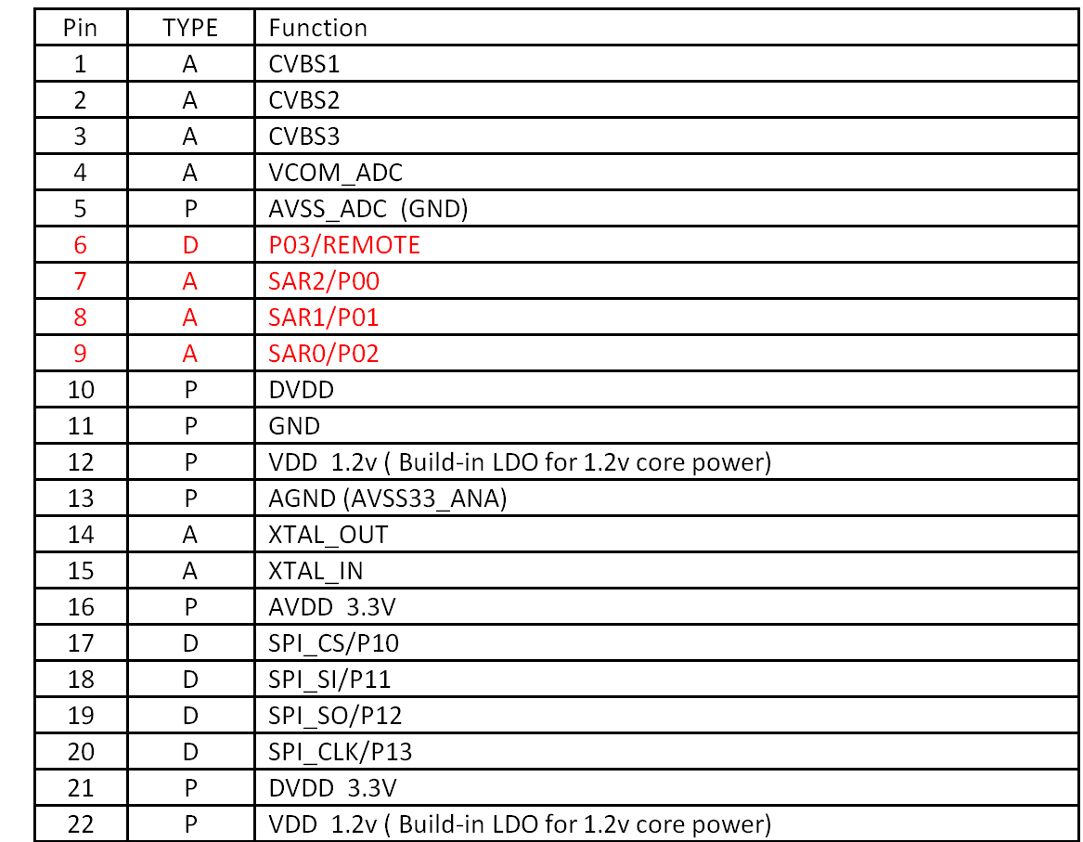
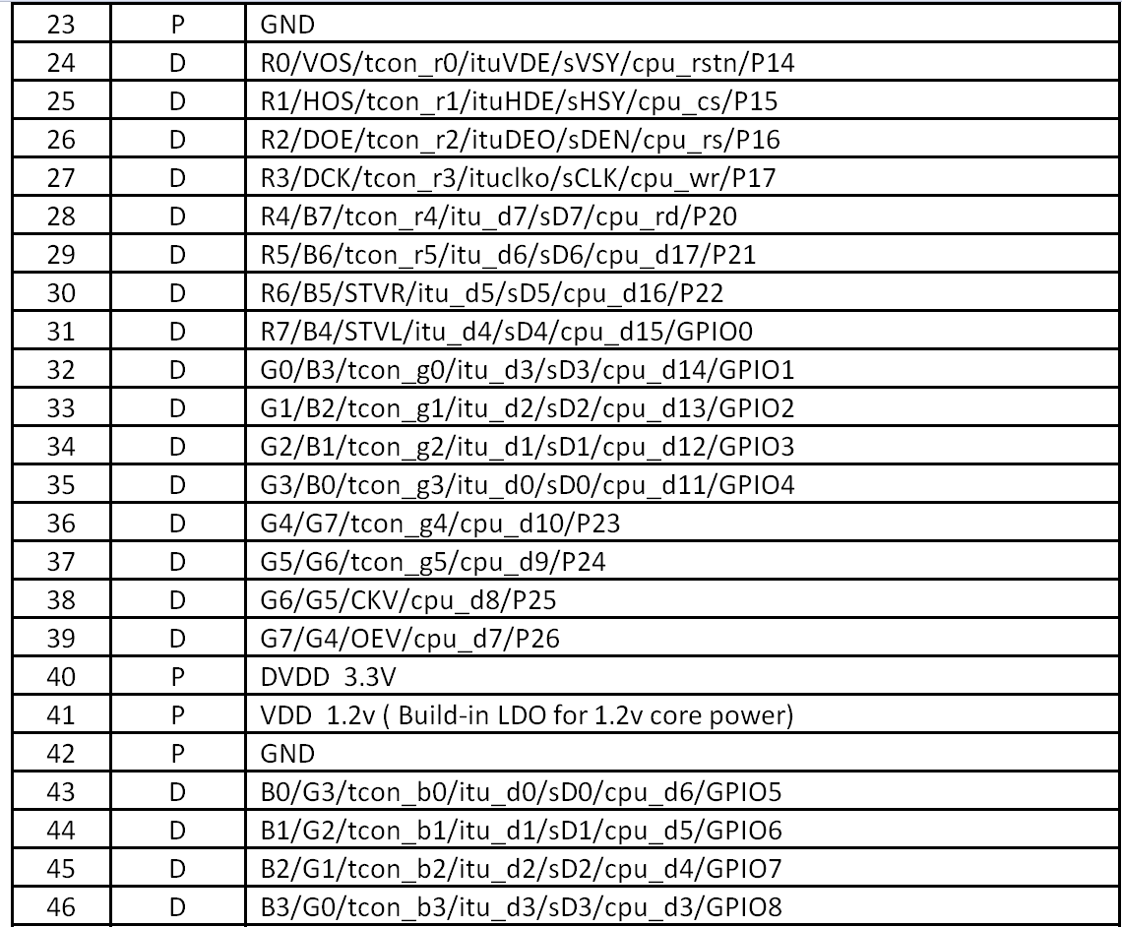
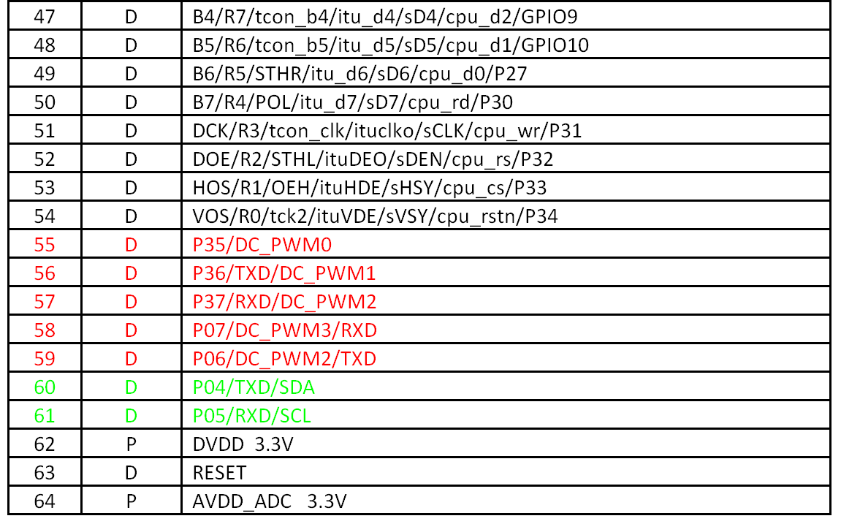
Red Pin can be used as a GPIO function, a total of nine ports.
Green Pin indicates the debug port. Generally, it is not recommended to reuse other functions. If multiplexing is required, it can only be used as an output port. A total of two.

I – C Screen interface :
AMT630A supports RGB888, RGB666, SRGB, CPU, D-TCON, and so on . It can support 1024x768 resolution or above .

II - ??
II A - Keil 4 compiler debug development environment
Description : Keil tools need to be unified.
AMT integrated 8051 microcontroller, we use the Keil software tools to compile the program, with SourceInsight software to edit. In fact, editing tools do not require any requirements, you can use personal favorite editing tools to edit the software. But for Keil's tools, we require customers to use and our unified version to compile. Keil because of the compatibility issues may be found in the debugging of some high-Keil version is not compatible with our current version of the software. This can lead to some strange problems, such as: procedures for no reason reset, run fly, and so on.

So customers need to use our Keil debugging tools to compile our software, which we need to know. Here are some of our Keil versions:
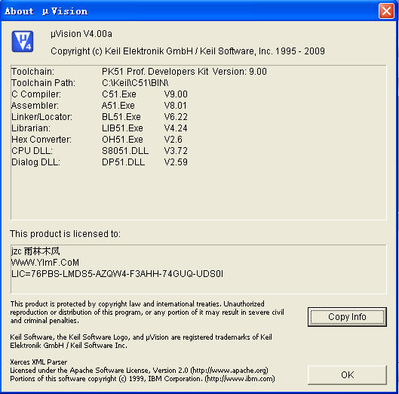

II B - Instructions for debugging tool :

AMT630 debugging tools is not convenient to use. AMT630A debugging interface and AMT630 is not the same. So this upgrade to the debugging tool board has also been upgraded, as follows is the new debug board PCB LAYOUT:

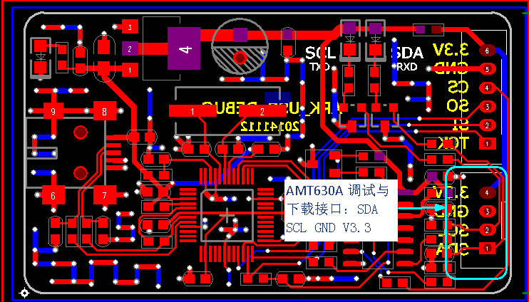

The debug board does not require the underlying driver, with ARK_DEBUG (AMT630A version), you can directly use. If you have previously used AMT630 tools do not need to re-install the driver, if you have not used may need to install FTDI USB to serial driver. Please refer to the installation method (software-driven installation instructions below)

II C - Software-driven installation instructions
Description: PC Tool Driver Installation Instructions

Debug AMT630A used ARK_DEBUG (AMT630A version)

We provide to the customer's development kit which has this tool driver. See the red box
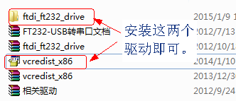安装这两个驱动可 = Install both drivers
Installation is very simple, you can directly click. After the installation is complete, open the ARK_DEBUG.exe can see the PC more than two ports ComXX ComXX +1, two ports are coexistence, the first port is USB-> I2C, the second is USB-> UART.

We need to select the first port namely: ComXX.
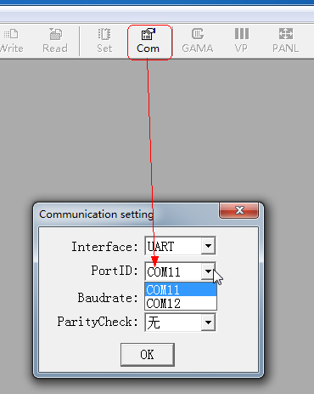
If you open the picture to see p3 that has been installed successfully.

II D - ARK DEBUG debugging tools to use

Description: Describes the differences between AMT630A and AMT630

AMT630A debugging tools use ARK_DEBUG_AMT630A.exe The main function of this tool is to see (software-driven installation instructions):

1. Screen parameter debugging, including image decoding, image effects, image position and other function module parameter debugging.
2. Software download function, including a single download, bulk download, this feature is described separately. See (Software Download Method II E).
3. Screen integration function, the target screen parameters integrated into the application software.
4. Screen management function, the main user OK debugging screen parameters for LIB management, to facilitate customers to quickly find the required screen parameters.

The toolbar function buttons are as follows:
P2

(a) Select the corresponding Com port, click on the "Com" button pop-up the following dialog box:

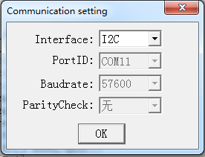P3
The default communication mode is I2C communication. By default, the COM port with the smallest Com ID number is selected. If the driver is installed, there will be at least two COM ports at the same time. The ID number is continuous. For example: Com11 Com12, I2C communication mode , Because Com12 is the UART communication port.

(b) After selecting the COM port, the next step is to open a screen parameter and connect the debug line (SDA, SCL, GND) to the target board and click "Link". At this point in the Output window prompts whether the connection is successful: The picture shows the success tips:
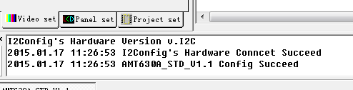P4

The following picture shows the error: the solution see (debugging tool connection is not a successful solution).
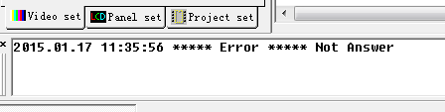P5
(c) After the connection is successful, you can double-click the register can read and write access tool has been able to work properly.
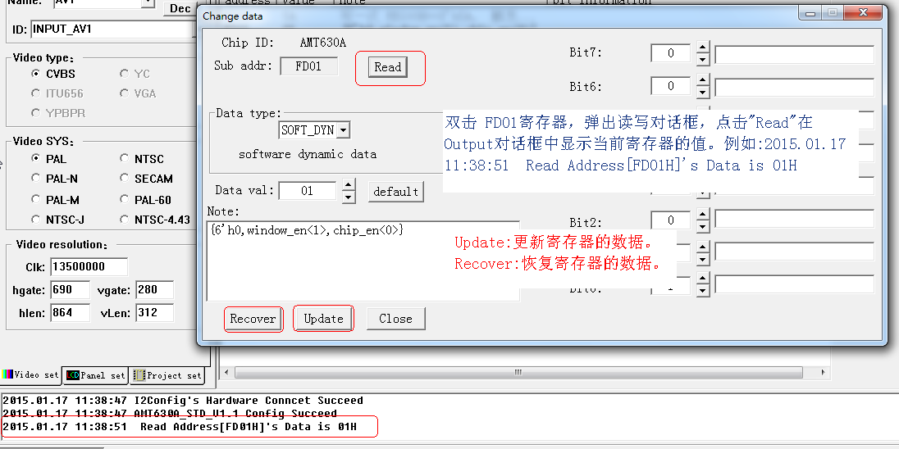P5
双击 FDOI寄存器, 弹出读写对话框, 龚于寻击~Read′在output对话框中显示当前寄存器的值. 筱鲑女口:
=>Double-click the FDOI register, pop-up read and write dialog box, Gong in the search ~ Read zai Output dialog box shows the value of the current register.

Update:更新寄存器的数据. : Updates the register data.
RecoVer:ˉ恢复寄存器的数盏居. Restore the number of registers.

(d) Next, enter the debugging process. First of all need to know the current image of the image format is PAL or NTSC or other. Click "ARK" 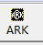pop-up:
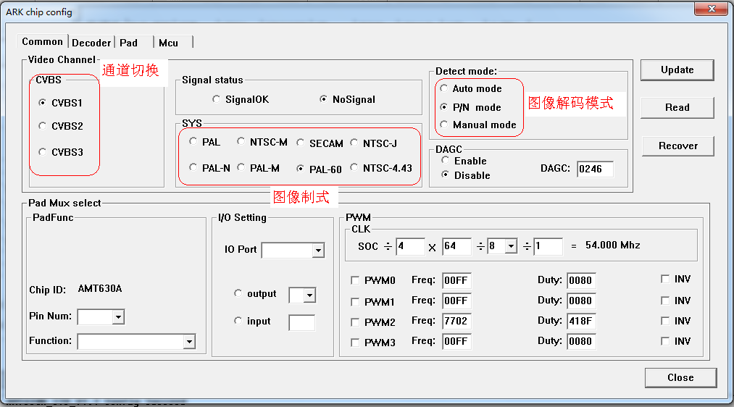

通道切换 : Channel switching
图像解码模式 : Image decoding mode
图??式 : Image

Click the "Read" button to see the SYS box indicating the current image format. If the current PAL, then the following dialog box need to select PAL:
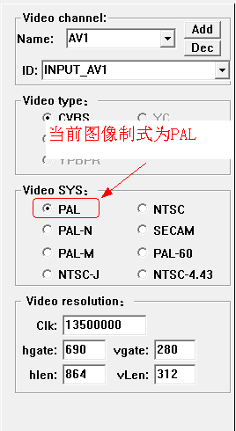P9
当前图像箫I]式为PAL : The current image is PAL
(E) Next you can click on the "GAMA" 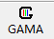 pull GAMA curve:
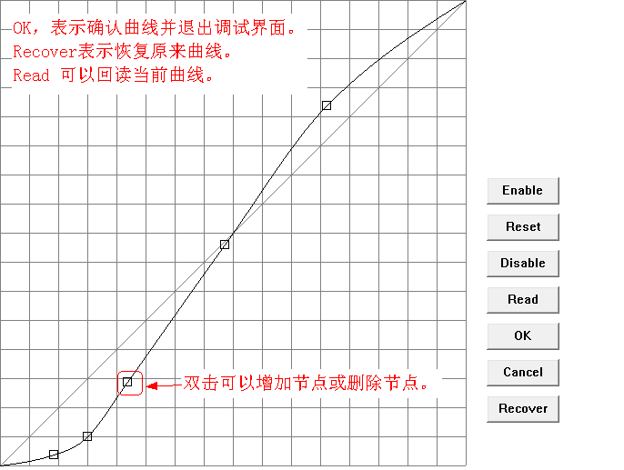
OK, 表示确认曲线并退出调i式界面. => OK, that confirm the curve and exit the i-type interface.
Recover表示恢复原来曲线. Recover means to restore the original curve.
Read 可以回读当前曲线. Read can read back the current trace.
双击可以增力口节点或删j除节点. Double-click to increase the force of the node or delete j in addition to nodes.
(6)click"VP"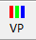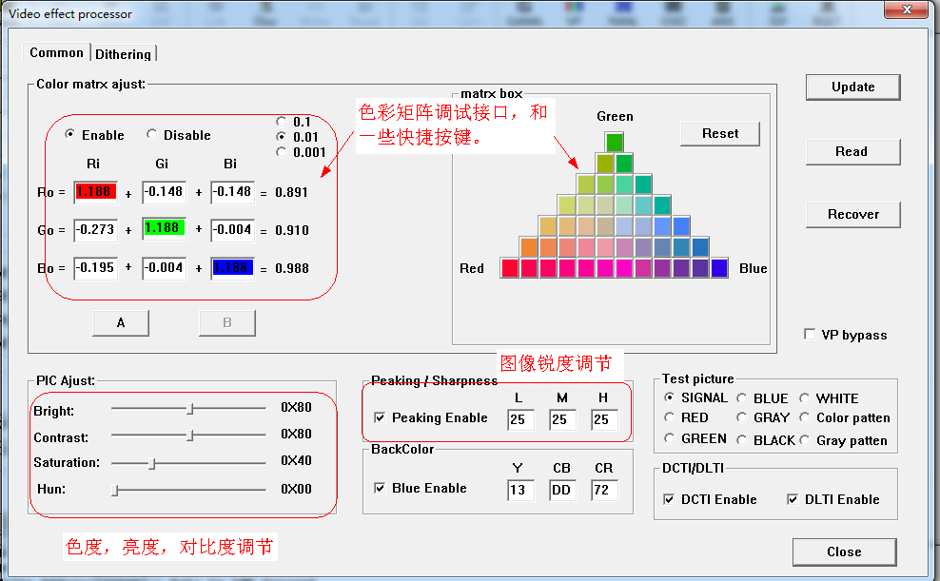
色彩矩阵调???口, he 一些快捷按键: Color matrix transfer i-style concubine mouth, and some shortcut keys.
图像锐度调节 : Image sharpness adjustment
色度, 亮度, 对壮匕度调节 : Chroma, brightness, on the dagger degree adjustment

(7) click "PANL" pop-up 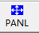:
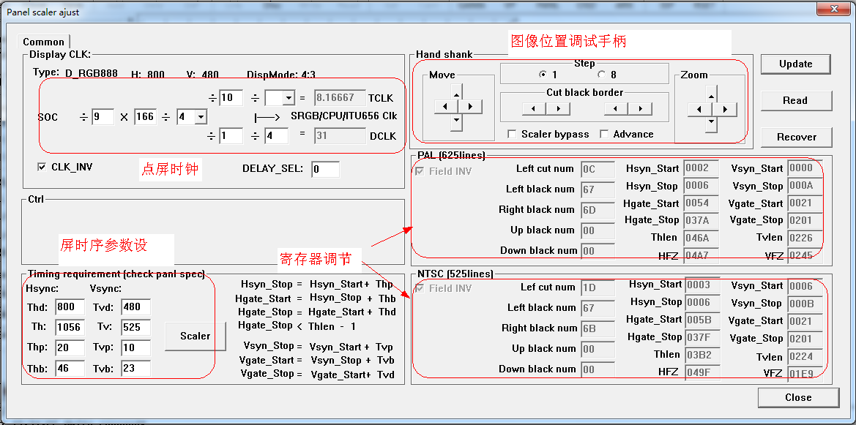
图像位?调?手柄 : Image bit-tone type handle
点屏时钟 : Point screen clock
屏时序参数设 : Screen timing parameters set
寄存器调节 : REGISTER ADJUSTMENT

(8) click "OSD" pop-up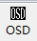:
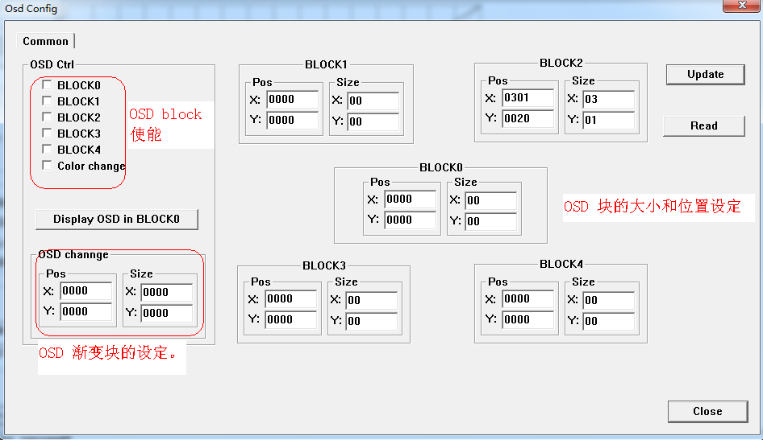
OSD block ???
OSD 块的大 xiao he位设定 : OSD block of large little and position settings
OSD 渐变块的设定. : OSD Gradation block settings.

(9) click "ISP" pop-up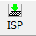:
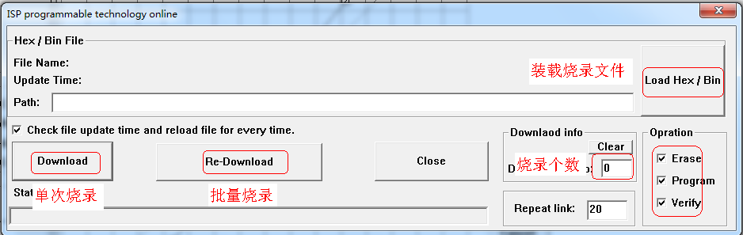
单次烧录 : Single burning
批量烧录 : Batch burning
装载烧录文儡牛Load the file
烧录个数 : The number of burns

(10) Click "REST" to reset the system 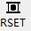

II – E Software download method
Description: Describes how to download AMT630A

AMT630A is to use I2C to download the program, the interface line for the SDA SCL GND can, in order to facilitate debugging we have to download and debug interface together. Then AMT630A how to download the program:
First open ARK_DEUBG, click "ISP" 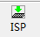 download dialog box:
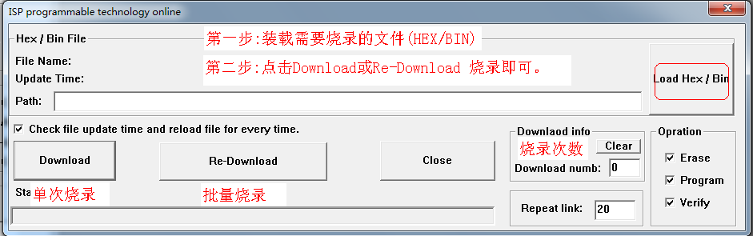
第一步:装载需要烧录的文儡牛(HEX/B工N) Step 1: Load the file to be burned (HEX / B)
第二 步 二 点击Download或Re一Download 烧录且口 可 . Step 2 Click Download or Re-Download.
烧录次数 : Number of burns
单次烧录 空比量烧录 : Single Burst Space Ratio Programming

For example :
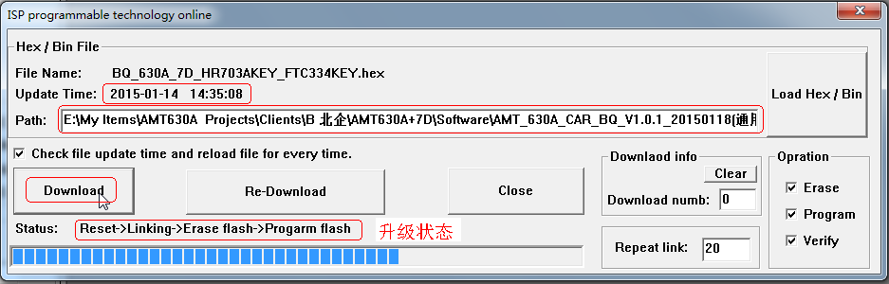
升级状态 : Upgrade status

Automatically restart after burning.

II F - Debug tool connection unsuccessful solution
Description: What to do if AMT630A debugging tool is not working properly

ARK_DEBUG.exe connection is not successful when the solution is as follows:

Step 1: Verify that the tool driver is installed OK, it also exists on a group of Com port, ComID continuous, if there is success.

Step 2: Confirm whether to choose the correct communication protocol and COM port, please see (ARK_DEBUG debugging tools use).

Step 3: Click "Link" to see if there is flashing LED indicator, if it is, the tool board is intact. If you find that the LED is always bright, it indicates that the debugging port of AMT630A is the output port and needs to be powered on again.

Step 4: Make sure the connection is correct, debug and download only SDA SCL GND three lines, V3.3 can be ignored.

Step 5: Make sure that the application software of AMT630A has frequent serial port printout. If it is, you need to remove frequent printing and re-programming.

Step 6: If after the above five steps or there is a problem, there may be damage caused by AMT630A, replace the IC.

III ????
III – A : How to replace the AMT630's underlying driver with the AMT630A.

In order to make AMT630A rapid mass production, the need to AMT630A the underlying transplantation to the AMT630 software and transplantation AMT630A itself with the two-step method of logic.
The following is the process of transplanting the underlying driver:

(A) replace AMT_Reg.h After the completion of the replacement software, there are some storage is not defined, for example:
VCOM_AC --- does not exist
VCOM_DC --- does not exist
PWMCtrl --- exists, location has changed
PWMARateL --- present, position has changed
PWMARateH --- present, position has changed
PWMBRateL --- present, location has changed
PWMBRateH --- present, position has changed
CLK_GateEn --- exists, location has changed
ADC_Control --- present, position has changed
AMP5En --- does not exist
SEL_CVBS_SVIDEO --- Present, position has changed
ALIGN_DEL --- does not exist
OSD_H_SCALE_H_BK0_COEF --- exists, location has changed
BITMAP_SATRT_ICON --- present, position has changed
AC_ChgRate --- does not exist
Normal_Y_Mulcoef --- does not exist
Normal_Y_Subcoef --- does not exist
Bias_Pwm_Rate --- exists, position has changed
LED_Pwm_Rate --- present, position has changed

Some of these registers do not exist, and some changed the address, so the next register does not exist to delete, the address has been changed to temporarily shield the register, in the shield marked AMT630A, convenient follow-up to find replacement.

(2) replace the AMT_Drv.c replace the completion of the compiler software and found that some functions do not, or more variables and functions, or function the same but there is a function header file declarations and function definitions exist parameter type differences.
1. For the missing function can be temporarily shielded call, and add AMT630A annotation to facilitate the follow-up to find.
2. For more variables or functions how to shield more functions or variables, and marked AMT630A, to facilitate the follow-up to find.
3. There are differences between function definitions and declarations, and there are differences between variable definitions and declarations. For example: POS_GetIrKeyVal function
UINT POS_GetIrKeyVal (void) - Function definition, UCHAR POS_GetIrKeyVal (void); - Function declaration, so the compile is prompted for a redefine error.
4. The existence of L1, L2 WARNING warning is due to the lack of corresponding macro definition, the lack of macro definitions can be copied and pasted.
5. Note AMT630 software UCHAR POS_GetIrKeyVal (void) function returns UCHAR, g_ucRemoteKeyVal is UCHAR, and AMT630A use UINT type, need to UCHAR, keep the same and the original logic.

According to the process of error and L1, L2 warning can be resolved.
In addition to the corresponding closure of the following modules, in the back of a module to open a transplant.
#define FlashEn
// # define KeyDetectEn // key detect enable switch
// # define IrDetectEn // remote detection enable switch
#define BacklightEn // Backlight control enable switch
// #define CarBackEn // reversing enable switch
// # define PannelSfrDispEn // Screen special display enable switch (flip)
// #define IrABCtrlEn // has IrAB enabled switch
// #define PowerLedEn // power light enable switch
// # define BuzzerEn // the buzzer enable switch

(C) replace AMT_Osdbootdrv.c replace the complete compilation software. Found some macro definition did not, or some variable type does not correspond, etc., has been the error and warning can be resolved.

(D) to add AMT30A screen parameters, enabling screen participation until the completion of the compiler.

(5) replace the video LIB, compiler warning exists L1, DetectSignalSys function no longer exists, you need to replace the AMT630A image format detection function.

(6) replace IO LIB, according to the corresponding control IO to modify the foot, such as backlight control IO, screen flip and so on.

(7) replace Debug.c, and I2C_SCL I2C_SDA, such as I2C and Uart pad configuration copied over, then # # define Release_Ver open serial debugging mode, until the successful translation.

(8) to replace the SetT2BaudRate (ULONG Brate), because AMT630A use 27MHZ crystal, and AMT630 use 24MHZ, so the baud rate count needs to be modified, or print error.

() To replace AMT_Mcu.h, and watchdog initialization and removal function transplanted, for example: void InitialWatchDog (void), void POS_ClearWatchDog (void), add DisableWatchdog (); function in the ConfigMcuCtrl ();

(10) After the above debugging process, the backlight should be able to light up. Next, the OSD is debugged. Since AMT630A has different character size than AMT630, we need to call OsdIconSize (ICON_SIZE_X, ICON_SIZE_Y) in the void InitOSD (void) function to set the OSD character size. Some modifications need to be made as follows:
1. AMT630A material list as a result of changes in the location of the list, ENGLISH is possible, but other languages ​​need to make changes according to the list of locations.
2.OSD fontRam characters need to re-create, because the original is 12 * 16, and now is 16 * 22, so the material needs to be re-done.
3.OSD position adjustment.
4. Adjust the lower case to uppercase.
5. Adjust the OSD material index according to the multi-language.

(11) 16: 9 and 4: 3 logic needs to be modified, migration void ConfigDispZoomDynPara (UCHAR currentmode) function.

(XII) image format detection, with or without signal detection underlying transplantation.

(XIII) If it is reversing the display program, then we must transplant reverse module.
1. MSG POS_GetUserDefinedMsg (FLAG timer) function to replace.
2. Set the g_sysSetting.Car.status assignment or compare statement macro to remove the MSG_ prefix, and add the typedef enum _CarStatus enumeration definition in global.h.
3. Replace CarReversingCDetectEn with CarReversingSignalDetectEn.

After the above transplant steps, this has been basically the AMT630A the underlying transplanted to the AMT630 application software, the next need to test out the problems continue to debug one by one solution.

III B – AMT SDK Falsh address space allocation instructions.
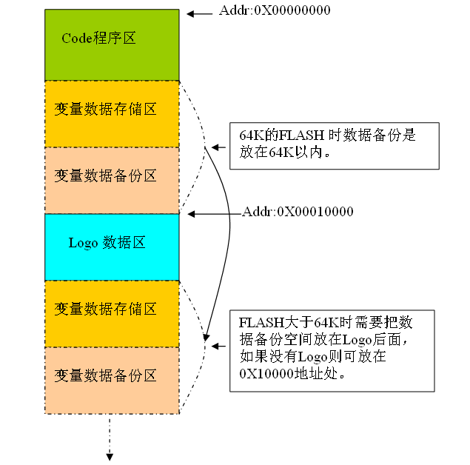
Code Program Area <- Addr: 0X00000000
Variable data storage area <- 64K FLASH data backup is on the 64K or less.
Variable data backup area
<- Addr: 0X00010000
Logo data area
Variable data storage area
Variable data backup area
<- FLASH greater than 64K need to put the data backup space on the Logo behind, if there is no Logo can be placed in the 0X10000 address.

1.Code program area, we generally support 64K bytes, if the jump bank can support 2M bytes of the program interval.

2. Variable data storage area, used to save the system to adjust the analog and other variables need to be saved, the data size of 4K bytes space.

3. Variable data backup area, for the variable data storage area of ​​a data backup, to prevent data loss, the data size of 4K bytes of space.

4.Logo data area for the Logo data storage, according to Logo size to determine the space occupied. If there is no Logo then this space can be used to put the variable data to save, if you have a Logo then you must start from 0X10000 address.

Then we AMT SDK for FLASH space allocation from where to decide, see Figure 1.

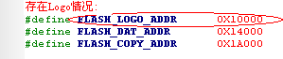
figure 1
Above for our 64K project FLASH space allocation instructions. If the project is 128K need additional planning, continued after. . .

III C - Description of the AMT software file framework

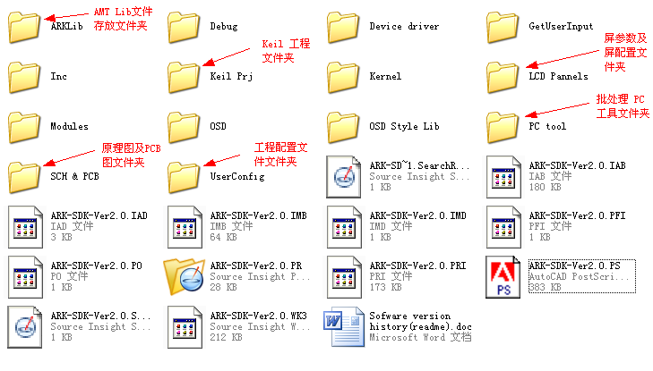
The following describes the AMT software file framework:

(P 1)

Click "Keil Prj" to enter:
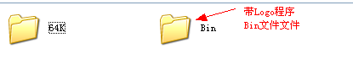

Click "64K" to enter:
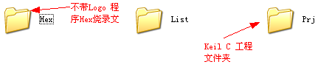

Click "LCD Pannels" to enter:
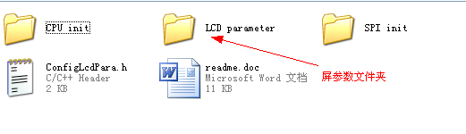
Click "OSD"
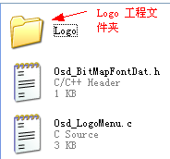
III D - How to update the LIB provided by ARK

Description: Explains how to update the ARK to provide a new LIB.

How do I replace AMTLib?
How to update the ARK sent to the LIB software?

1. First, update the LIB library sent from the ARK to the folder where the LIB is placed:
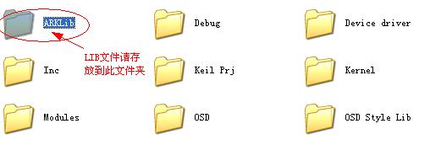

2. Then open Keil to add LIB as shown below:
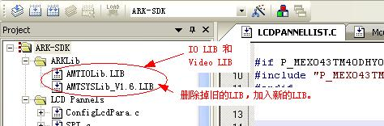

After the LIB has been updated, recompile the program.

III E – KEY

AMT ADC range
AMT630A the ADC voltage range: 0 ~ 3.3V, if the ADC button to do, it is recommended that each key voltage interval> 0.1V or more.

ADC key instructions
(A) of the ADC channel Description:
AMT630A chip, can provide three-channel ADC_12Bit channel, the input voltage range of 0 ~ 3.3V, each channel set the voltage interval of not less than 0.1V.

(B) ADC button settings:
1, Prj_AMT_SDK_DEMO.h open the following key detection enable switch # define KeyDetectEn;

2, Prj_AMT_SDK_DEMO.h Define KEY_TYPE as ADC_KEY;

3, Prj_AMT_SDK_DEMO.h the following configuration ADC KEY key board;
Eg: #define hw_upResistance 12000 / / 12k pull-up resistor
#define hw_downResistance 0 // 0: no pull-down resistor
#define hw_keyVoltage 3.3 // voltage
#define ADC_CH_LIST {CH1} // Detect the channel list
#define ADCKEY_PAD_ID KP_ARK_SDK_V01 // ADC keypad ID
#define KEY_OFFSET 5 // The offset of the ADC key
#define RepeatTime 0X07 / / ADC continuous key response time

4, KP_V01.h ADC button configuration below the actual value and the corresponding macro button command;
// Key Val
For example: #define hw_KEY_POWER makeUint16 (CH1, hw_keyAdcVal (0)) / / the first parameter for the channel information, the latter parameter is the corresponding key resistance.
#define hw_KEY_SOURCE makeUint16 (CH1, hw_keyAdcVal (27000)) // The previous parameter is the channel information, and the latter parameter is the resistance value of the corresponding key.
...
...
// Key Cmd Map
KeyCmdMap CODE SysKeyCmdMap [] =
{
{Hw_KEY_POWER, KEY_POWER}, // previous parameter is the definition of key values, the latter parameter is the key type
{Hw_KEY_SOURCE, KEY_SOURCE_SWITCH},
...
}}

5, configure the ADC button macro command corresponding to the message;
Eg: KeyMsgMap CODE SysKeyMsgMap [] =
{
{MSG_UPK_POWER, KEY_POWER}, // Previous parameter is the key message, the latter parameter is the key type
{MSG_UPK_SOURCE_SWITCH, KEY_SOURCE_SWITCH},
...
}}
Attached: This array can be found in GetUserInputMsg.c file, usually in the AMT SDK already exists, do not need to add, if not, you need to manually add.

7, Osd_MenuKeyInterface.h Next, configure the corresponding message processing commands;
Eg: KeyComdInterface CODE RootMenuItem_KeyComdMap [] =
{
// Conditions Comd Msg Source
{InputPress, COMD_Power, MSG_UPK_POWER, ALL_INPUT_SOURCE},
{InputPress, COMD_SelSource, MSG_UPK_SOURCE_SWITCH, ALL_INPUT_SOURCE},
...
}}

/ / The first parameter is to get the key condition, the second parameter is the key to generate the command, the third parameter is the key to generate the message, the fourth parameter is generated by the key channel information
InputHold: long press function, inputPress: short press function.
Attachment: This array is generally in the AMT SDK has its own, do not need to add, if not, need to manually add, and add the appropriate command processing functions.

(C) Description of the correlation function:
UINT POS_GetAdcKeyValue (void) / / return to the current channel acquisition ADC button value.
UCHAR POS_TransferAdcKeyCmd (UINT KeyVal) // Returns the corresponding ADC keypress command according to the ADC key value.
KeyInfor POS_TransferKeyMsg (UCHAR KeyCmd) / / According to the ADC button command, return the corresponding ADC key message to the application layer.

How to Debug ADC Keys

Description: AMT630A potentiometer debugging method.
Below to discuss the process to achieve ADC KEY function:

1, the first step: Prj_AMT_SDK_DEMO.h header file # define KeyDetectEn open

2, the second step: Prj_AMT_SDK_DEMO.h find the following code, and modify.
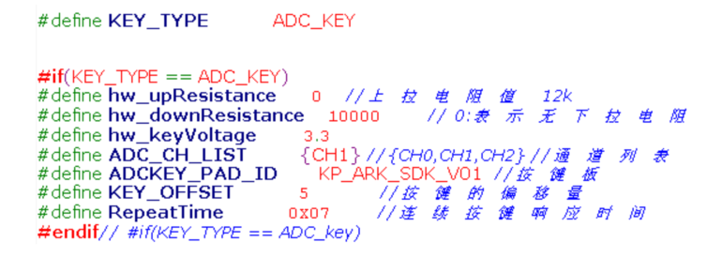
This step requires reference to the circuit diagram, we need to know in the circuit diagram is the pull-up or pull-down resistor, the voltage is, and then determine what keypad, the most important is which ADC channel we are channel 0 (CH0), channel 1 (CH1), or channel 2 (CH2).

3, the third step, the configuration is as follows:
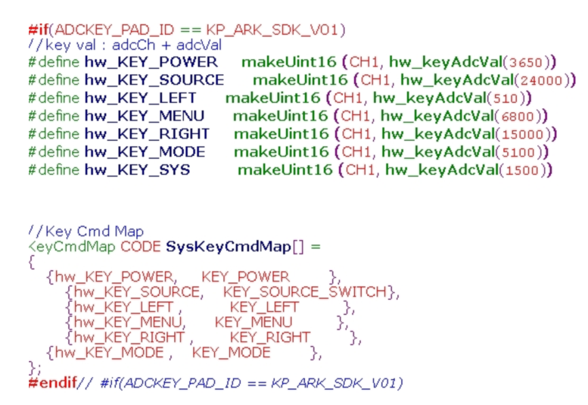
For these parameters we need according to the key board and its actual function to configure.

Finished these three steps, the bottom of our key things to finish, follow-up is the application layer operation.
Google Traduction pour les entreprises :Google Kit du traducteurGadget Traduction

How to swap ADC button functions
We often encounter debugging, KE1 and KE 2 function reversal, please modify the following diagram:
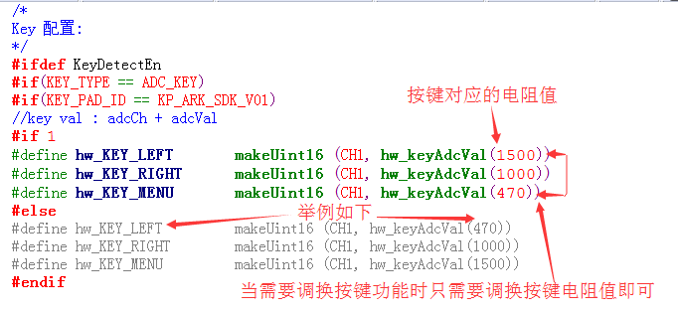
How does AMT630A solve the problem of pulley function reverse.
Customers can set a custom keypad in the program, as shown below:
Figure P1

Figure P1 is the keypad definition in Prj_AMT_7D_SDK_DEMO.h.

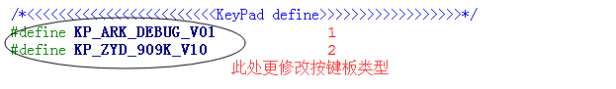Figure P2
Figure P2 is a different hardware.h in the instructions, where you can increase or decrease the different key board.

How to achieve the short press button and long press function

In the process of debugging the keys, some customers require a long press button and short press to achieve different functions in the AMT SDK V1.3 software version of the above changes by responding to the KeyComdMap table button can easily set the long press and short press Features.

The following source switch key short press is the source switching function, long press the shutdown function as an example to explain. RootMenuItemKeyKey in Osd_MenuKeyInterface.h under the AMT SDK project
DMap to add 2 key response messages.

{InputPress, COMD_SelSource, MSG_UPK_SOURCE_SWITCH, ALL_INPUT_SOURCE},
{InputSpHold, COMD_Power, MSG_UPK_SOURCE_SWITCH, ALL_INPUT_SOURCE},

No need to modify the bottom of any other key logic, to achieve the source switch key short press the switch source, press the shutdown function.
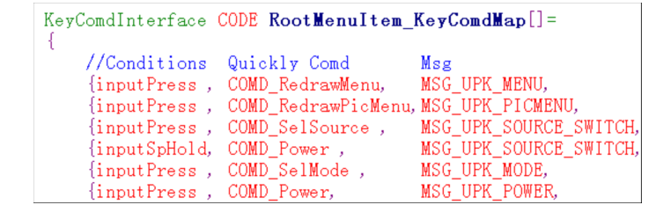

Corresponding to the same COMD_Power inpuSpHold and inputPress have two different MSG generation, namely: MSG_UPK_SOURCE_SWITCH and MSG_UPK_POWER.

GPIO button adjustment
(A) GPIO button settings:
1, Prj_AMT_SDK_DEMO.h open the following key detection enable switch # define KeyDetectEn;

2, Prj_AMT_SDK_DEMO.h Define KEY_TYPE as GPIO_KEY;

3, Prj_AMT_SDK_DEMO.h the following configuration potentiometer;
Eg: #define GPIO_KEY_COUNT 3 // number of GPIO KEY keys
#define GPIO_KEY_VALID 0 // GPIO KEY key valid state
#define RepeatTime 0X07 / / continuous GPIO KEY response time
#define GPIO_KEY0 GetP1_0 () // KEY0 corresponding to the GPIO port
#define GPIO_KEY0_CMD KEY_CONTRAST // KEY0 corresponds to the function
#define GPIO_KEY1 GetP1_1 () // KEY1 corresponds to the GPIO port
#define GPIO_KEY1_CMD KEY_LEFT // KEY1 corresponds to the function
#define GPIO_KEY2 GetP1_2 () // KEY2 The corresponding GPIO port
#define GPIO_KEY2_CMD KEY_RIGHT // KEY2 The corresponding function

Appendix: According to conventional, the current AMT SDK GPIO button configuration can be up to 3, if necessary, can be added.

How does the AMT630A address pulley function reversal?

Replace the key functions of the GPIO, as shown below:
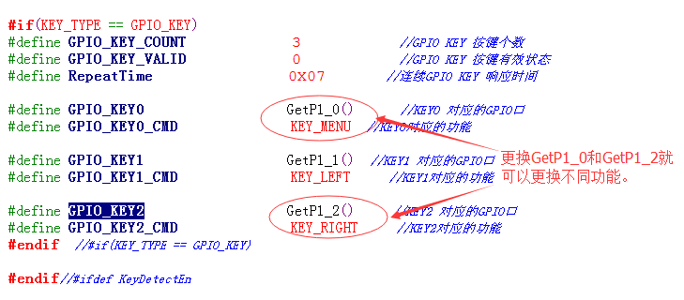P1

In the GPIO_KEY definition, modify the different GPIO selection, you can replace the key.

How to switch the key adjustment type
At present, we AMT SDK can support the key type is the ADC button, GPIO button, IIC touch buttons, pulleys and so on.
We are through the macro:
# Define KEY_TYPE settings to determine the key type, as shown below:
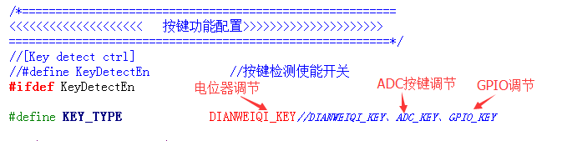

WT5700 key instructions
(A) WT5700 button settings:
1, Prj_AMT_SDK_DEMO.h open the following key detection enable switch # define KeyDetectEn;

2, Prj_AMT_SDK_DEMO.h below definition KEY_TYPE for IIC_KEY;

3, Prj_AMT_SDK_DEMO.h below according to different hardware design, configuration WT5700 and AMT series chip for communication;
Eg: #define hw_Key_getSDA_input () GetP1_0 () // SDA
#define hw_Key_setSDA_output (x) SetP1_0 (x) // SDA
#define hw_Key_setSCL_output (x) SetGPIO0 (x) // SCL

4, Prj_AMT_SDK_DEMO.h WT5700 key board configuration below;
Eg: #define Port1ReleaseVal 0X00 // WT5700 Reg 0X08 Popup value
#define Port2ReleaseVal 0X00 // WT5700 Reg 0X09 Popup value
#define I2CKEY_PAD_ID KP_ARK_SDK_V03 // Keypad ID
#define RepeatTime 0X07 / / continuous button response time

5, KP_V03.h The following configuration WT5700 button actual value and key corresponding macro command;
// Key Val
Eg: #define hw_KEY_POWER 0X08
#define hw_KEY_SOURCE 0X0A
...
// Key Cmd Map
KeyCmdMap CODE SysKeyCmdMap [] =
{
{Hw_KEY_POWER, KEY_POWER},
{Hw_KEY_SOURCE, KEY_SOURCE_SWITCH},
...
}}

6. Configure the corresponding message of WT5700 key macro command;
Eg: KeyMsgMap CODE SysKeyMsgMap [] =
{
{MSG_UPK_POWER, KEY_POWER},
{MSG_UPK_SOURCE_SWITCH, KEY_SOURCE_SWITCH},
...
}}
Attached: This array can be found in GetUserInputMsg.c file, usually in the AMT SDK already exists, do not need to add, if not, you need to manually add.

7, Osd_MenuKeyInterface.h Next, configure the corresponding message processing commands;
Eg: KeyComdInterface CODE RootMenuItem_KeyComdMap [] =
{
// Conditions Comd Msg Source
{InputPress, COMD_Power, MSG_UPK_POWER, ALL_INPUT_SOURCE},
{InputPress, COMD_SelSource, MSG_UPK_SOURCE_SWITCH, ALL_INPUT_SOURCE},
...
}}

/ / The first parameter is to get the key condition, the second parameter is the key to generate the command, the third parameter is the key to generate the message, the fourth parameter is generated by the key channel information
// inputHold: long press function, inputPress: short press function.
Attachment: This array is generally in the AMT SDK has its own, do not need to add, if not, need to manually add, and add the appropriate command processing functions.

(B) Description of the correlation function:
Initial_WT5700 (void) // Initializes the WT5700
UCHAR ReadWT5700 (UCHAR subAddr) / / read WT5700 related register values
UINT POS_GetI2CKeyValue (void) // Get the WT5700 keypress value
UCHAR POS_TransferI2CKeyCmd (UINT KeyVal) / / according to WT5700 key values, return to the corresponding WT5700 key command.
KeyInfor POS_TransferKeyMsg (UCHAR KeyCmd) / / According to the WT5700 key command, return the corresponding WT5700 key message to the application layer.

The Setting Method of AMT630A Potentiometer.
(A) potentiometer settings:
1, Prj_AMT_SDK_DEMO.h Open the following key detection enable switch # define KeyDetectEn;

2, Prj_AMT_SDK_DEMO.h Define KEY_TYPE as follows: DIANWEIQI_KEY;

3, Prj_AMT_SDK_DEMO.h The following configuration potentiometer;
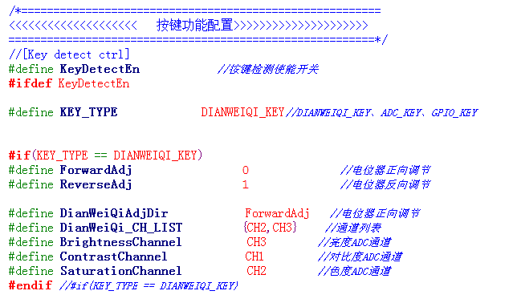 Attached: AMT630A chip can have up to 3 ADC port, the current potentiometer AMT SDK can adjust the brightness, contrast, color, if necessary, feasible to add.

How to adjust the potentiometer reverse

Some customers sometimes require the potentiometer pulley to be adjusted in the opposite direction. Please modify the following macro values:

#define DirectionMode NOR is positive, INV is reverse
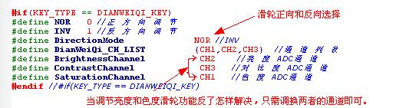

How to solve the potentiometer adjustment function anti
When we debug the doorbell project, we often encounter the function of the anti-pulley, for example: pulley should be adjusted brightness, into the debug contrast. At this point we should be in the following procedures can be modified.

The following example mainly addresses the adjustment of the color wheel and the brightness of the pulley
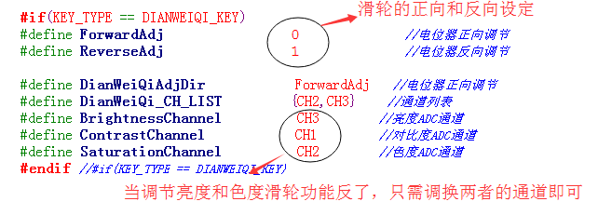

III F – GPIO

GPIO instructions

AMT630A IO port has two types: P port and GPIO.

P port: MCU IO port itself, with P0-P3, a total of 32 months.
GPIO: ARK expansion IO port, there are GPIO0-GPIO10, a total of 11 months.

How to control IO status through IIC file
Description: AMT630A IO port control method.

AMT630A IIC can be used to temporarily control the IO port as input & output, as shown in Figure P1:
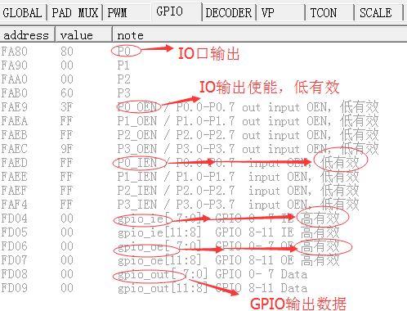P1

GPIO settings and applications are as follows:

1, in the ARK-Debug tool to select ITEM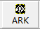, will pop up the settings page, as shown in Figure P4:
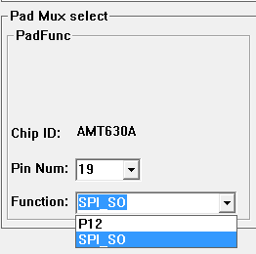P4

The PIN with PAD_MUX function is PIN6-PIN9, PIN17-PIN20, PIN24-PIN39 and PIN43-PIN61. Select the corresponding Pin Num (detailed PIN corresponding to the function, you can refer to the data AMT630A_PAD_MUX), and then select the appropriate Function can.

2. In the function area shown in the following figure P5 / P6, you can select the GPIO input / output function.

Output: select the specific port IO Port, and then select the output in the output 1/0, corresponding to the output is high / low.
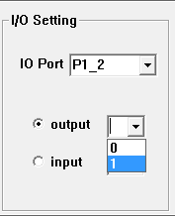P5

Input: set the function is input, and then click on the input can read the detailed state of the port.
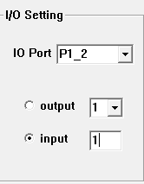P6

3, the process has been done in the GPIO package library, only need to call SetPX_X and GetPX_X can set the corresponding IO state.
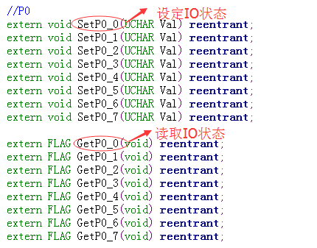P7
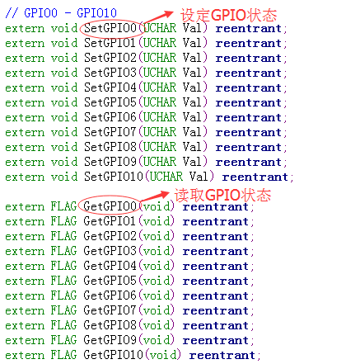P8

AMT IO resource description
PAD_MUX Legend Description:
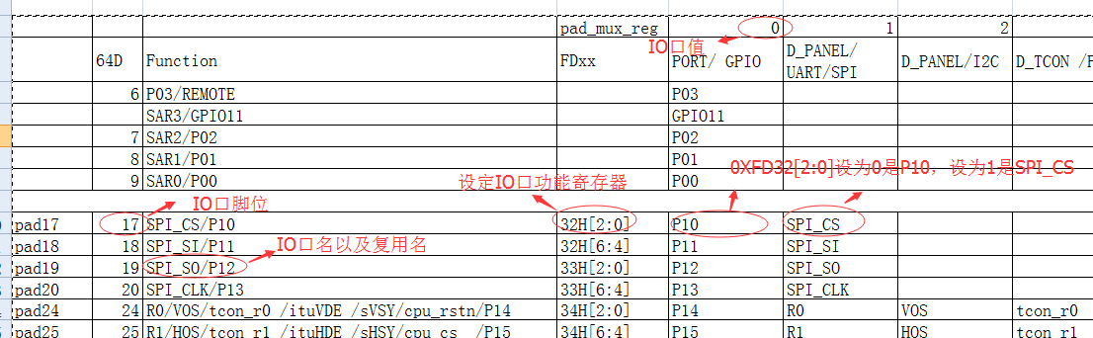

VOIR tableau dans le CHM

III – G How to add a new remote control to the software:
Chapitre pas traduit

III – H SDK
AMT software main line process description
Si besoin car long

IV – PCB conseils et example, voir fichier dans le dossier

V - OSD debug documentation
V A - OSD Resources, and architecture documents - OVERVIEW
OSD resources include:

1, FONT ROM, curing a total of 418 internal 16X22 characters in the chip, including the six countries of Japan and South Korea, Russia and Thailand, Ukraine, Bulgaria, Turkey and other 15 languages, the characters are as follows:
=>START
P1

0 is the space, INDEX RAM is 0X00, the first one is 0, INDEX RAM is 0x01, and so on.

2, FONT RAM 4kX16bit, you can write up to 186 16X22 characters or 46 16X22 16-color BITMAP. FONT RAM INDEX starts at 0x1C0.

3,5 OSD BLOCKs, 3 blinking areas, 16 palettes to BITMAP, and 8 palettes for normal ICON. BITMAP Color Palette Swap Enable. ICON size can be set, it is recommended to set to 16X22, the maximum can be set to 24X32. You can set the horizontal or vertical direction of the OSD image, character zoom function.

V B - OSD tool for the use of documentation
Discription: OSD Tools OsdMatrix Instructions for Use

OsdMatrix is mainly used for word formation and LOGO. The realization of these two functions have specific documentation, this document will not repeat, mainly on the use of OsdMatrix control.
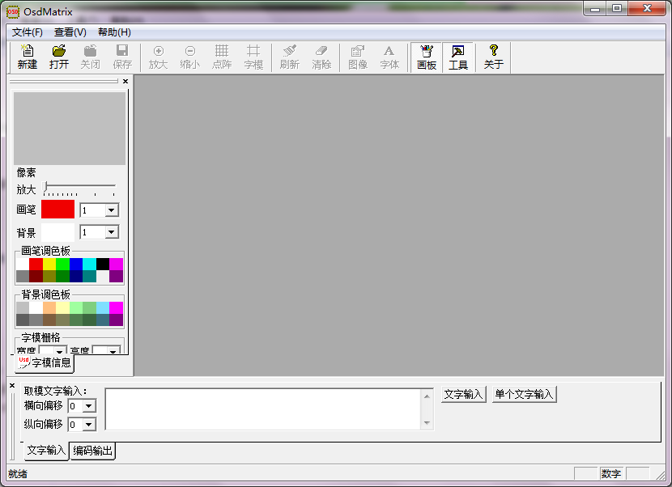P1

"ZOOM UP" "ZOOM DOWN" is the view zoom, does not change the size of the picture. ICON size can be set to set the size of an ICON size, the general use of the default value of 16X22.
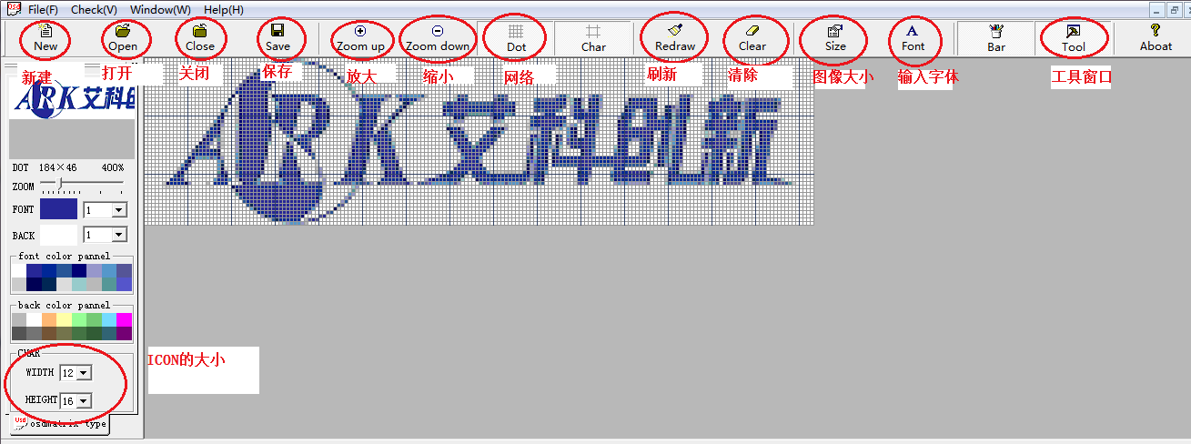P2

"SIZE" come in to set the image size, set the point "SUER", the picture refresh to set the size.

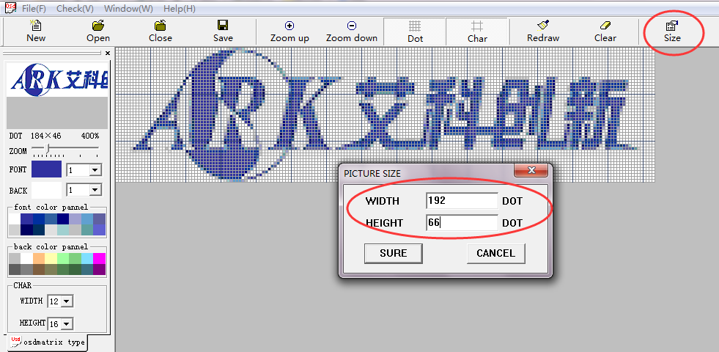P3

LOGO output settings as shown below:
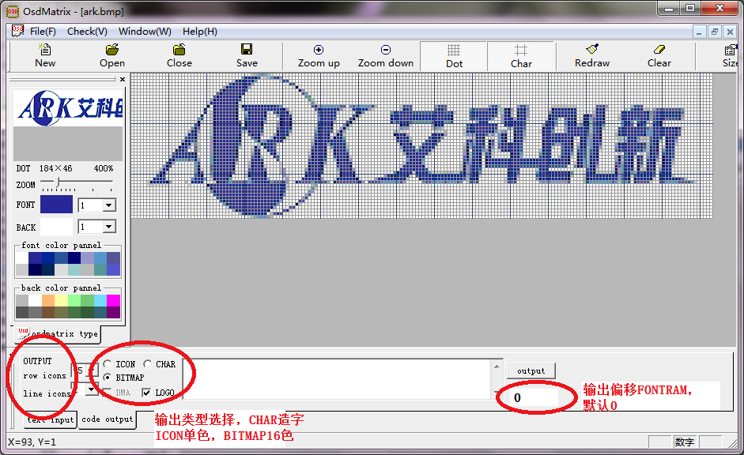P4

V C - The OSD displays the underlying documentation
This document describes the procedure for displaying the "AMT630A" on the OSD in the manner that the underlying register is operated.

1, open the OSD layer, there BLOCK0 to BLOCK4 can choose, here with BLOCK0

XBYTE [0XFB05] = 0X41; / / open BLOCK0, unified foreground background color, written by reg0XFB2A

2, OSD block size, just opened the BLOCK0, so set the size of BLOCK0
XBYTE [0XFB07] = 0X0A;
XBYTE [0XFB08] = 0X02;

3, OSD block location
XBYTE [0XFB09] = 0X00; / / OSD position high
XBYTE [0XFB0A] = 0X50;
XBYTE [0XFB0B] = 0X50;

4, write OSD foreground color and background color;
XBYTE [0XFB2A] = 0X12; // foreground color is palette 2, background color is palette1

5, to the palette color
Palette 1 Write red:
XBYTE [0XFB56] = 0X0f;
XBYTE [0XFB57] = 0X00;
Palette 2 Write Blue:
XBYTE [0XFB58] = 0X00;
XBYTE [0XFB59] = 0X0f;

6, write </ span> INDEX, "AMT630A" FONTROM INDEX is "0x0b, 0x17,0x1e, 0x07,0x04,0x01,0x0b"
XBYTE [0XFB0D] = 0; // INDEX_RAM_ADD_H
XBYTE [0XFB00] = 0; // INDEX_RAM_ADD_L
XBYTE [0XFB0E] = 0; // INDEX_RAM_DATA_H
XBYTE [0XFB00] = 0x0B; // A
XBYTE [0XFB0E] = 0; // INDEX_RAM_DATA_H
XBYTE [0XFB00] = 017; // M
XBYTE [0XFB0E] = 0; // INDEX_RAM_DATA_H
XBYTE [0XFB00] = 0X17; // T
XBYTE [0XFB0E] = 0; // INDEX_RAM_DATA_H
XBYTE [0XFB00] = 0X07; // 6
XBYTE [0XFB0E] = 0; // INDEX_RAM_DATA_H
XBYTE [0XFB00] = 0x04; // 3
XBYTE [0XFB0E] = 0; // INDEX_RAM_DATA_H
XBYTE [0XFB00] = 0X01; // 0
XBYTE [0XFB0E] = 0; // INDEX_RAM_DATA_H
XBYTE [0XFB00] = 0x0B; // A

V D - The OSD displays the process documentation
Discription: OSD Displays the flow description
Below to a small menu as an example of the 630A SDK OSD display process:

1, the brightness shortcut keys generated when the command COMD_Brightness, BOOL ExectComd (ComdType OpratComd) in response to the command
………. 1000 images voir CHM
V E - OSD character production documentation
Voir CHM

V F - Osg Matrix tool to add LOGO
Voir CHM

VI - Slave Debugging documentation
VI A - Slave mode needs attention
Sometimes customers will use the AMT630A Slave mode to do the product, in the use of Slave mode need to pay attention to the following:

First, how to enter the Slave mode?

First need to set the device address 0XBE, Sub address 0XC6 register is configured to 0X40, enter the IIC control mode.

Second, how to set Slave address?

Set the device address 0XB0, Sub address 0X09 of the register is configured as 0X7F, and then configure other registers, to be the other register configuration is complete, then this register with 0XFF.

The following figure P1 is AMT630A do Slave mode IIC corresponding device address:
Suite dans le CHM. Ca a l’air optionel.

VII - Tune the screen debug documentation
VII A - AMT630A debugging instructions
AMT630A chip supports ordinary digital screen, Tcon digital screen, cpu screen, srgb screen, itu656 output, itu601 output. The following is a point of a variety of screen need to pay attention to matters for reference purposes only.

1, the general digital screen: a DE mode, HV mode.

Clock: The dot screen clock DCLK is the same as the data processing (scaler, osd, vp ...) clock. It is recommended to configure dis_clk_div_reg (0xFD15) to 0x80 or 0x01 and sca_clk_div_reg (0xFD14) to configure the corresponding different values ​​according to different screens.
Timing: Refer to "VII B".
OSD: In order to keep the OSD position in P / N mode consistent, you need to select different OSD positioning signals (line and field signals) according to different modes. See the 0XFB89 register for details. DE mode, select hden, vsyn; HV mode, select hsyn, vsyn. In DE mode, hden, vsyn select rising edge positioning, HV mode, hsyn, vsyn need according to the point screen timing to select the rising edge or falling edge, with the screen start bit, see register 0XFB35 bit 3 And 5th.

2, Tcon digital screen:

Clock: The dot clock tclk1, tclk2 is the same as the data processing (scaler, osd, vp ...) clock. It is recommended to set tpll_div_reg (0xFD1A [2: 0]) to 7, dis_clk_div_reg (0xFD15) to 0x80 or 1, and sca_clk_div_reg (0xFD14) to the same value as tcon_src_div_reg (0XFD16) to configure different clock frequencies according to different screens.
Timing: Refer to "VII B".
OSD: In order to keep the OSD position in P / N mode consistent, you need to select different osd positioning signals (line and field signals) according to different modes. See the 0XFB89 register for details. According to the different screen selection sthl, sthr, shvl, stvr, should be consistent with the screen timing.

3, CPU mode : 18-bit screen/……………….. 16-bit screen / 8-bit data line, 18-bit screen / 8-bit data line, 18-bit screen / 18-bit data line, 24-bit screen / 8-bit data lines
Clock: In different modes, the screen clock and the data processing (scaler, osd, vp ...) different clock frequency, configuration values ​​are different.
18-bit screen / 18-bit data line, 16-bit screen / 18-bit data line, point screen clock and data processing clock frequency is the same, dis_clk_div_reg (0xFD15) configured 0x80 or 1.
18-bit screen / 9-bit data line, 16-bit screen / 8-bit data line, point screen clock is twice the data processing clock frequency, dis_clk_div_reg (0xFD15)
18-bit screen / 8-bit data line, 24-bit screen / 8-bit data line, point screen clock is the data processing clock frequency 3 times, dis_clk_div_reg (0xFD15) Sca_clk_div_reg (0xFD14) Configures different values ​​for different frequency clocks depending on the resolution of the different screens.
Timing: Refer to "VII B". In order to maintain the integrity of the entire field, P / N switching needs to be synchronized at the time of the field, so scale register pn_pos_mod (0xFcE3 [5]) to be 1. Tcon register data_refresh_en (0xfc0e [5]) need to be allocated at the end of 1, that is, the screen parameter configuration is complete, cpu screen initialization is complete, switch to hardware mode and then open the bit to enable.
OSD: 0XFB89 register, need to select hden, vsyn signal.
Configuration: According to the different mode screen configuration different parameters cpu_scr_mode (0xFC0f).

4, Srgb screen: srgb with dummy, srgb without dummy, syuv422

Clock: In different modes, the dot screen clock sclk and data processing (scaler, osd, vp ...) clock frequency relationship between the different configurations. Srgb with dummy mode, dot screen clock sclk is 4 times the data processing clock, dis_clk_div_reg (0xFD15) configured to 4. Srgb without dummy mode, dot screen clock sclk is 3 times the data processing clock, dis_clk_div_reg (0xFD15) is configured to 3. Syuv422 mode, dot screen clock sclk is 2 times the data processing clock, dis_clk_div_reg (0xFD15) configured to 2. Sca_clk_div_reg (0xFD14) Configures different values ​​for different frequency clocks depending on the resolution of the different screens.

Timing: Refer to "VII B". Note: In different modes, the initialization parameter thbp (line sync to valid data points) is required when the screen is initialized. Srgb with dummy mode, thbp should be a multiple of 4; Srgb without dummy mode, thbp should be a multiple of 3; syuv422 mode, thbp should be a multiple of 2.

OSD: 0XFB89 register, you need to select hsyn, vsyn signal. Hsyn, vsyn need to screen according to the timing of the screen to select the rising edge or falling edge, consistent with the screen start bit, see register 0XFB35 the third and fifth.

5, itu656, itu601 Output:

Clock: The dot screen clock is twice the clock frequency of the data processing (scaler, osd, vp ...) and dis_clk_div_reg (0XFD15) should be 2.
Timing: Refer to "VII B".
OSD: 0XFB89 register, need to select hden, vsyn signal.

VII B - AMT630A timing configuration details
1, the register configuration

Before configuring each scale register, you need to know: input data clock CLKin, input effective number of lines Hin, total number of input lines Hin_all, input field number of lines Vin, the number of input lines Vin, output line The effective number of points Hout, the output of the field number of lines Vout.

1.1 Output line, field ordered configuration (NTSC, PAL)
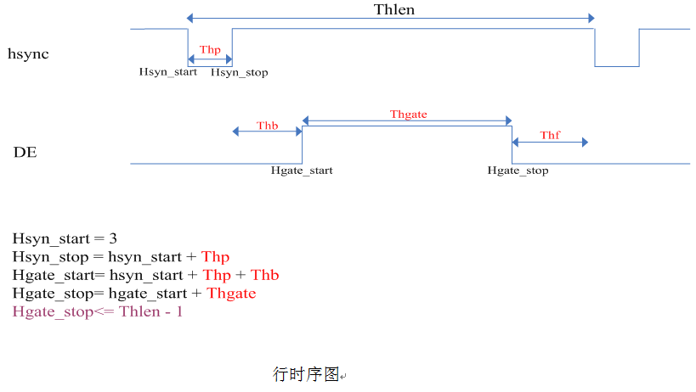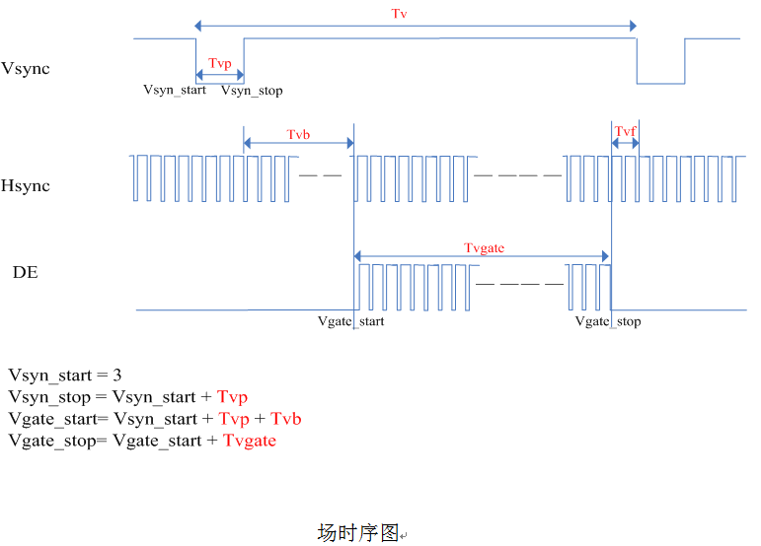

In the above diagram (line timing diagram) shows the hsync and DE relative position and configuration register method, in which DE that the line is valid signal, hsync said line synchronization signal. Related registers are Hsync_start, hsync_stop, Hgate_start, Hgate_stop, which, Hsyn_start general now set a fixed value (3), Hsyn_stop = Hsyn_start + Thp (line sync width). Hgate_start = Hsyn_start + Thp + Thb, Hgate_stop = Hgate_start + Thgate. The number of rows is the same as the line width.

Thlen is the total number of points in one line. The method is Thlen = (Hout / Hin) * Hin_all, where Hout is the dot width, Hin is 720 and Hin_all is 864 or 858. The formula based on the scale clock at this time as the principle of value, if the scale clock deviation, it should be a corresponding change in the value of THLEN, other appeal three values ​​remain unchanged. Specifically, if the clock is faster than the theoretical value, increase the value of THLEN. If the clock is slower than the theoretical value, decrease the value of THLEN. As for the specific value of increase or decrease, in the case of knowing the actual scale clock clk_scale_real and the ideal scale clock clk_scale_ideal, the following equation can be used:

THLEN_real = (clk_scale_real / clk_scale_ideal) * THLEN

It should be noted that the final Thlen should be greater than Hgate_stop +1.

Thlen value of the calculation to take into account the more trouble is to increase the Thlen automatic adjustment function. Only need to configure a close Thlen value (should be greater than Thgate_stop + 1), the hardware will automatically adjust a suitable Thlen value, and register REGE5, REGE6 can read, read out the register configuration.

In addition, in the horizontal direction, if you want to left the image, left_cut_num can be used to cut the previous value. To turn the image to the right, use left_black_num to fill the previous image with black pixels.

In the above figure (field timing diagram), the field synchronization signal vsync, the horizontal synchronization signal hsync and the relative position of the active signal DE, and the configuration-related register are shown. Vsyn_start represents the starting position of the line synchronization, usually a fixed value (such as 3), Vsyn_stop = Vsyn_start + Tvp (field sync width, the number of rows). Vgate_start represents the effective start position of the field, Vgate_start = Vsyn_start + Tvp (field sync width) + Tvb (field sync back shoulder), Vgate_stop represents the field valid end position, and Vgate_stop = Vgate_start + Tvgate (effective line number, screen height).

Adjust the position of the field direction, usually with Vsyn_start to adjust, DE mode can also be used Tvb, that Tvgate_start to adjust. In addition, up_black_num can be cut from top to bottom image is black, down_black_num cut from top to bottom image is black.

1.2 horizontal, vertical up / down configuration

Horizontal up / down by the input of each line of the effective number of points and the output of the effective number of points per decision, can also be artificially configured by the register. Under normal application, only need to know the input and output points to configure the corresponding scaling factor HFZ, the hardware will automatically respond up / down.

VFZ> 1024, VFZ> 1024, when VFZ <1024, VFZ> 1024, when the scale is up scale, it is equivalent to the straight-through.

1.3 The scaling factor HFZ, VFZ configuration

HFZ is a 16-bit register, HFZ = (Hin / Hout) * 1024

VFZ is a 16-bit register, VFZ = (Vin / Vout) * 1024

1.4 SCALE Other register configurations
See the register descriptions for additional registers.

Sample 1:
(Hin = 720, Hin_all = 858, Hout = 480, Vin = 240, Vin_all = 262, Vout = 240, Clkin = 13.5M) for the NTSC system source point 480x240.
Clk_scale: [(Hout * Vout) / (Hin * Vin)] * Clkin = [(480 * 240) / (720 * 240)] * 13.5 =
Thlen: total number of lines ------------ (Hout / Hin) * Hin_all = (480/720) * 858 = 572
HFZ = (720/480) * 1024 = 1536
VFZ = (240/240) * 1024 = 1024

Note: The above parameters are based on clk_scale ideal value of the corresponding value, if clk_scale deviation, the corresponding adjustment Thlen value, the actual clk_scale greater than the ideal value, then increase Thlen value, the actual clk_scale less than the ideal value, The value of Thlen is decreased.

Sample 2:
Up scaler
Ninning point 800x480 digital screen: (Hin = 720, Hin_all = 858, Hout = 800, Vin = 240, Vin_all = 262, Vout = 480, Clkin = 13.5M)
Clk_scale: Hout * Vout / Hin * Vin * Clkin = [(800 * 480) / (720 * 240)] * 13.5 = 30 M
Thlen: Total number of lines ------------ (Hout / Hin) * Hin_all = (800/720) * 858 = 953
HFZ = (720/800) * 1024 = 922
VFZ = (240/480) * 1024 = 512

2 common parameters incorrect phenomenon:
A green frame representing an input image window;
The blue box represents the SCALER image window;
A red frame representing an output image window;

1, Thgate is too small (blue box is too small)


2, TCON WINH is too small

3, HFZ too

If there are too many missing points on the right edge, you need to adjust the line offset of the input SCALER.

4, position deviation

If the analog or digital TCON screen, adjust TCON HSHIFT & SCALER HV DELAY
If the digital screen (DEN drive) is adjusted VP REG DEN SHIFT & SCALER HV DELAY
If the digital screen (HV drive) is adjusted SCALER Thsync, Thgdel & SCALER HV DELAY

VIII - Program burn bad
Discription: Program burning problem solving
AMT630A production in the program encountered when customers can not burn the problem, that is in accordance with the normal programming process PC has been prompted to connect unsuccessful. The reason for this problem is that the AMT630A can run the AMT630 program because the AMT630A program is attached to the AMT630A board. However, the Padmux registers are not the same. This causes the configuration of the AMT630A upgrade port to be incorrect .

Therefore, the production of AMT630A when the customer must pay attention to the flash or have their own correct procedures, so there will not be this problem.

IX - Video Training Course
AMT630A video training tutorial

Video Tutorial:

1. How to connect the online debugging tool.
2. How to download the program to the AMT630A.
3. How to install the tool driver.
4. How to use the ARK_DEBUG debug screen parameter.
5. How to integrate the screen into the software.
6. How to use OSDMatrx to make OSD.
7. How to use the Offline Upgrade Tool.

Please e-mail to cjinzong@arkmicro.com for video training tutorial, thank you!

